Chapter 17, Solution 29.

This function is half-wave symmetric.

T = 2π, ω_{o} = 2π/T = 1, f(t) = −t, 0 < t < π

For odd n, a_{n} = 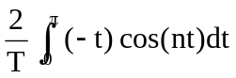 = 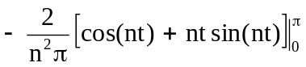 = 4/(n²π)

b_{n} = 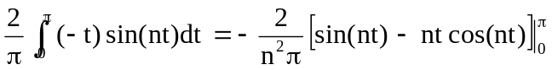 = −2/n
Thus,

f(t) = 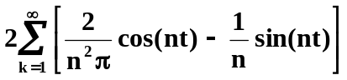, n = 2k − 1

